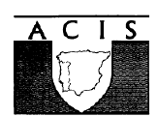

ASSOCIATION FOR
CONTEMPORARY IBERIAN
STUDIES

DRAFT

CONFERENCE PROGRAMME

University of The West of England, Bristol

6 - 8 September 2005

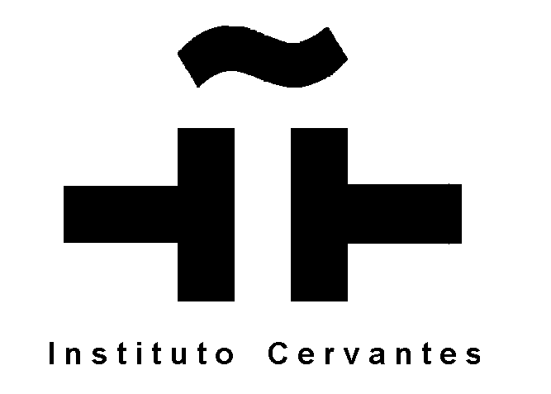

Version: 30 June 2005

Tuesday, 6th September

Registration: 11.30-12.30

Lunch: 12.30- 1.30

1.30-2.40 pm: Joint Panel

Collin McKinney, University of Cambridge

Visions and Divisions: Urban Spaces, Bourgeois Morality and Panoptic Strategies in Galdos’s Fortunata y Jacinta

Araceli Tinajero, CUNY (USA)

Pasión por la hoja: hacia una nueva lectura de La Tribuna de Emilia Pardo Bazán

Chair:

2.40-3.15: Parallel Session

Pedro Alcudia, Universidad de Málaga  La Enseñanza Superior en España en el espacio común europeo.  Chair: | Jackie Cannon, Oxford Brookes  University  You are what you eat: The Mediterranean diet in Spain  Chair:

3.15 - 4.00 : Plenary

Paul Heywood, University of Nottingham

'Thirty years since Franco: the contradictions of contemporary Spanish democracy'

Chair:

4.00 - 4.15 : Coffee

4.15 - 4.50: Parallel Session

Maggie Torres  Anarchism and Political Change: the reconstruction of the Confederación Nacional del Trabajo during the political transition to democracy in Spain, 1976-1979  Chair: | Antonio Gragera, Texas State University  Aspect, tense and modality in Spanish verbal system  Chair:

4.50 - 5.30 Parallel Session

Antonio Lázaro Reboll, University of Kent  Donna Fitzgerald, Univ. of Nottingham  Making light of it: etching and the female form in Rego and Goya  Chair: | Hugh O’Donnell, Glasgow Caledonian University  From Tale to Chronicle; The Long Road from Telenovela to Soap  Chair:

5.15 - 6.00 Plenary

Nick Rankin, BBC journalist

George Steer and the bombing of Guernica: the story of a story

Chair:

7.00: Vino de honor

8.00 : Dinner

Wednesday 7th September

9.30 - 10.40: Parallel Panel

Hillary Rollin, Oxford Brookes University  Squaring the circle: Implications of the latest modifications to Spain’s Ley de Extranjería  Chad M. Gasta and Leland L’Hote,  Iowa State University  Immigration and Street Entrepreneurship: a Case Study  Chair: | Gabrielle Carty, Dublin City University  A Comedy for the Post-War Era: Renewal, Transformation and Chance in La vida en un hilo, 1945 (E Neville)  Barry Jordan, De Monfort University  Amenabar and film narrative  Chair:

10.40 - 11.00: coffee

11.00 – 11.40 : Parallel Session

Peter Gold, UWE Bristol  Parsley Island – An overseasoned dispute?  Chair: | Mike Shade, University of Brighton  The music of Radio Tarifa  Chair:

11.40 – 13.00 : Joint panel

Sian Ewards, University of Wales Swansea

Citizenship and Identity; what role for Catalonia in the new Europe?

Eric Bienefeld, University of Bath

Political Dimensions of Basque Participation in the EU

Kathryn Crameri, Lancaster University

‘Centrality, Competitivenesss, Singularity’: Catalan identity and the Cultural Industries

Chair:

1.00-2.15 LUNCH

2.30 – 3.10 : Parallel Session

Fernando León-Solís, University of Paisley  La Costa Española: 'An English Country Garden'  Chair: | Margaret Anne Clarke, University of Porsmouth  Regional Desertification and water resource management in Portugal: the case of the Alqueva Dam  Chair:

3.10 – 4.00 : Plenary

Supported by the Instituto Cervantes

CARMEN ALBORCH, Diputada y exministra

Chair:

4.00 - 4.30: Tea

4.30-6.00

AGM: Annual General Meeting

6.30 – 7.30

Visit to Bristol

8.00 : Cena de Gala

Thursday 8th September

9.30 - 10.40: Joint Panel

Joao Cosme, University of Bristol

Spreading the Word: Portugal’s New Postcolonial Empire

David Corkill, Manchester Metropolitan University

The Politics of Commemoration in Portugal and Spain: the Iberoamerican Exhibition 1929-30 and the Exhibition of the Portuguese World 1940.

Chair:

10.40 - 11.00: coffee

11.00 - 12.10: Joint Panel

Bernadette O’Rourke (Dublin City University)

Fala galego: which one?

Máiréad Moriarty

The Sociolinguistic Effects of Minority Language Television: The Case of ETB-1

Chair:

12.10-12.30: CLOSING SESSION

12.30-13.30 - LUNCH & DEPARTURE

All session Chairs yet to be confirmed

